**Computer Hardware**

**Class Five**

**Lab 5**

|  |
| --- |
| Lab Objectives:  * Networking Cables |

# Networking cables

Networking cables are [networking hardware](https://en.wikipedia.org/wiki/Networking_hardware" \o "Networking hardware) used to connect one network device to other network devices or to connect two or more computers to share [printers](https://en.wikipedia.org/wiki/Printer_(computing)" \o "Printer (computing)), [scanners](https://en.wikipedia.org/wiki/Image_scanner" \o "Image scanner) etc.

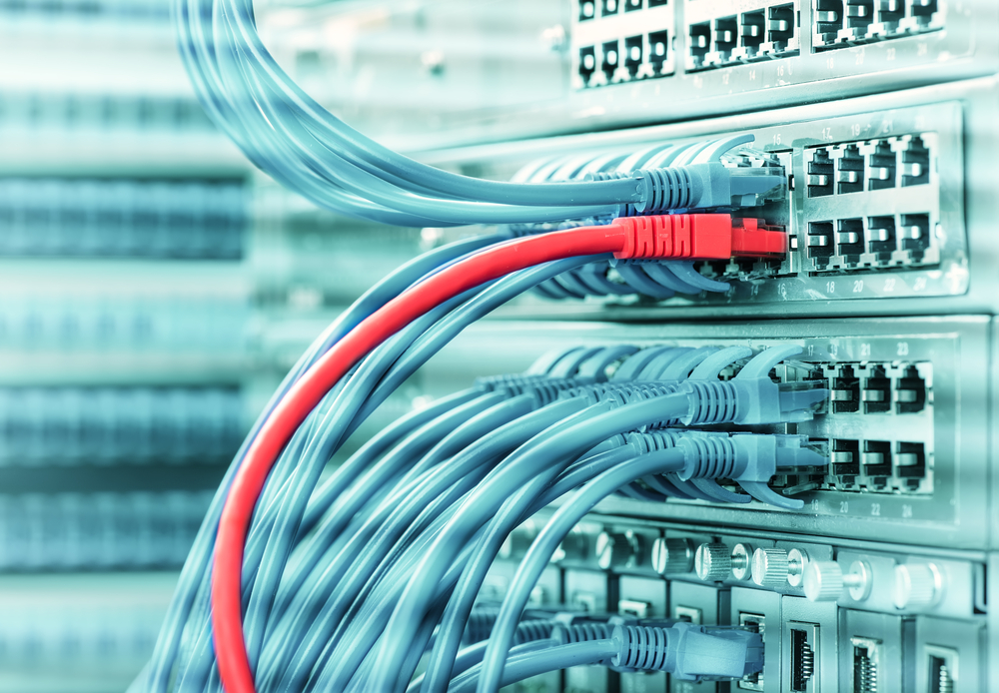

# Most Common Networking cables

## The most frequently used networking cables are: 1)Twisted Pair Cable 2)Coaxial Cables 3)Fiber Optic Cables 4)Universal Serial Bus (USB) Cables

# Twisted Pair Cable

## IMG_256A type of cable that consists of two independently insulated wires twisted around one another. The use of two wires twisted together helps to reduce [crosstalk](https://www.webopedia.com/TERM/C/crosstalk.html) and electromagnetic induction.

# Coaxial Cables

Coaxial cable is a type of copper cable specially built with a metal shield and other components engineered to block signal interference.

# IMG_256

# 

# Fiber Optic Cables

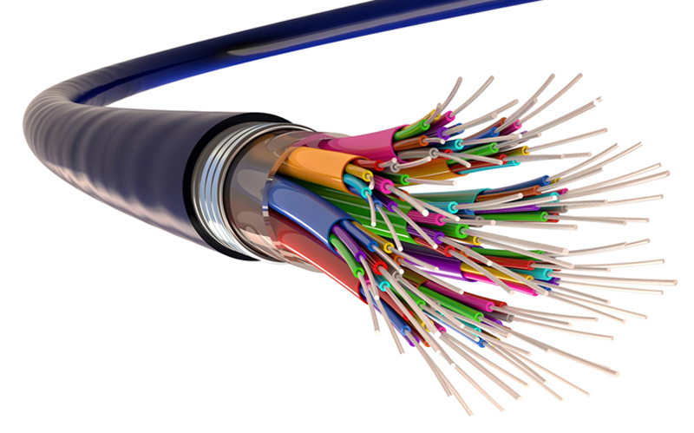

## a cable consisting of one or more thin flexible fibres with a glass core through which light signals can be sent with very little loss of strength is a fibre optic cable.

# USB Cables

## The term USB stands for "Universal Serial Bus". USB cable assemblies are some of the most popular cable types available, used mostly to connect computers to peripheral devices such as cameras, camcorders, printers, scanners, and more.

